**POC ON PRODUCT LISTING PAGE**

**ABOUT PROJECT**

**Objective :**

To render the product grid in the product listing page using react in salesforce commerce cloud.

**Code-base :**

[**https://github.com/sarthaks7harma/sfcc-react/tree/master**](https://github.com/sarthaks7harma/sfcc-react/tree/master)

**Technologies, Hardware, and Software Used :**

* **ReactJS** -

React is a JavaScript library for building user interfaces. It is maintained by Facebook and a community of individual developers and companies. React can be used as a base in the development of single-page or mobile applications, as it is optimal for fetching rapidly changing data that needs to be recorded. However, fetching data is only the beginning of what happens on a web page, which is why complex React applications usually require the use of additional libraries for state management, routing, and interaction with an API.

* **JSX -**

JSX, or JavaScript XML, is an extension to the JavaScript language syntax.Similar in appearance to HTML, JSX provides a way to structure component rendering using syntax familiar to many developers. React components are typically written using JSX, although they do not have to be (components may also be written in pure JavaScript).

* **JavaScript -**

JavaScript was initially created to “make web pages alive”. The programs in this language are called scripts. They can be written right in a web page’s HTML and executed automatically as the page loads. Scripts are provided and executed as plain text. They don’t need special preparation or compilation to run. In this aspect, JavaScript is very different from another language called Java.

* **React Bootstrap -**

React bootstrap replaces the Bootstrap javascript. Each component has been built from scratch as a true React component, without unneeded dependencies like jQuery. As one of the oldest React libraries, React-Bootstrap has evolved and grown alongside React, making it an excellent choice for UI foundation.

* **HTML and CSS -**

HTML (the Hypertext Markup Language) and CSS (Cascading Style Sheets) are two of the core technologies for building Web pages. HTML provides the structure of the page, CSS the (visual and aural) layout, for a variety of devices. Along with graphics and scripting, HTML and CSS are the basis of building Web pages and Web Applications.

**Code :**

Index.js :

import React from 'react';

import ReactDOM from 'react-dom';

import ProductGrid from './components/ProductGrid';

const data = [

{

imageurl:

"https://images-na.ssl-images-amazon.com/images/I/71XzSPb%2Bt1L._UL1500_.jpg",

id: "1",

name: "Pencil",

price: 1.84,

description:

"Perfect for those who !",

},

{

imageurl:

"https://assets.myntassets.com/f_webp,dpr_1.0,q_60,w_210,c_limit,fl_progressive/assets/images/1667077/2018/2/8/11518090736106-Roadster-Men-Black-Shadow-Checks-Casual-Shirt-1211518090735845-1.jpg",

id: "2",

name: "Housing",

price: 0.96,

description:

"Housing provided for out",

},

{

imageurl:

"https://assets.myntassets.com/f_webp,dpr_1.0,q_60,w_210,c_limit,fl_progressive/assets/images/7189947/2018/8/30/b0a17130-00b2-47dd-9acf-75fcdf7333111535614137835-Bene-Kleed-Men-Off-White--Blue-Slim-Fit-Printed-Casual-Shirt-3181535614137565-1.jpg",

id: "3",

name: "Computer Rental",

price: 300.04,

description: "Don't have a computer",

},

{

imageurl:

"https://images-na.ssl-images-amazon.com/images/I/71XzSPb%2Bt1L._UL1500_.jpg",

id: "4",

name: "Coffee",

price: 2.8,

description: "Wake up!",

},

{

imageurl:

"https://assets.myntassets.com/f_webp,dpr_1.0,q_60,w_210,c_limit,fl_progressive/assets/images/1265389/2018/2/7/11517995810352-Highlander-Black-Slim-Fit-Casual-Shirt-1061517995810069-1.jpg",

id: "5",

name: "Snacks",

price: 0.8,

description: "Free snacks!",

},

{

imageurl:

"https://assets.myntassets.com/f_webp,dpr_1.0,q_60,w_210,c_limit,fl_progressive/assets/images/2414313/2018/3/13/11520926368526-HERENOW-Men-Red--Black-Regular-Fit-Checked-Casual-Shirt-8881520926368447-1.jpg",

id: "6",

name: "Rubber Duckies",

price: 3.5,

description: "To help you solve your ",

},

{

imageurl:

"https://images-na.ssl-images-amazon.com/images/I/71XzSPb%2Bt1L._UL1500_.jpg",

id: "7",

name: "Fidget Spinner",

price: 21.99,

description: "Because we like to pretend ",

},

{

imageurl:

"https://images-na.ssl-images-amazon.com/images/I/71XzSPb%2Bt1L._UL1500_.jpg",

id: "8",

name: "Sticker Set",

price: 14.99,

description: "To prove to other devs",

}

];

ReactDOM.render(<ProductGrid products={data}/>,document.getElementById('react-app-plp'));

ProductGrid.js :

import React from 'react';

import ProductTile from './ProductTile';

export default function ProductGrid(products){

const len=products.products.length;

var arr=[];

for (var i=0;i<len;i++){

var a = <ProductTile key={products.products[i].id}

product={products.products[i]} />

arr.push(a);

}

return(arr);

}

ProductTile.js :

import React from 'react';

export default function ProductTile(props){

console.log(props.product);

return(

<div className="col-6 col-sm-4">

<div className="product-tile">

<div className="image-container">

<a herf={props.product.imageurl}>

<img

src= {props.product.imageurl}

alt="alt of image" title="title is nothing" />

</a>

</div>

<div className="tile-body">

<div className="pdp-link">

<a className="link" href={props.product.imageurl}>{props.product.name}</a>

</div>

<div className="price">

<span>

<span className="sales">

<span className="value" content={props.product.price}>{props.product.price}

</span>

</span>

</span>

</div>

</div>

</div>

</div>

);

}

productTiles.isml :

<div id="react-app-plp">

</div>

**OUTPUT :**

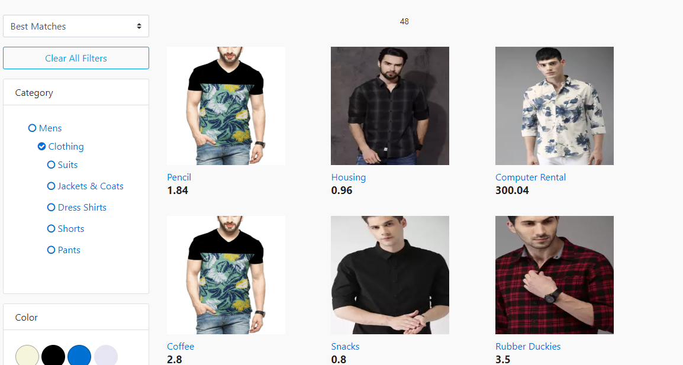

**How to implement the code :**

1. Replace the previous productTiles.isml with the new productTiles.isml

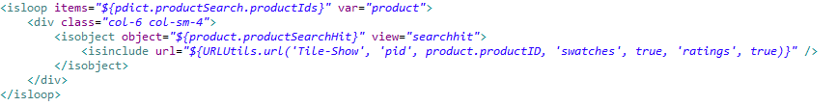

Previous



New

1. Add 2 javascript files :

-- ProductTile.js :

This .js is responsible for displaying the product grid on the

product listing page.

-- ProductGrid.js :

This .js will iterate through the data set.

1. Add the file containing the data :

Example: Index.js